Practical No.09
Configure and Verify a Site-to-Site IPsec VPN Using CLI
Network:
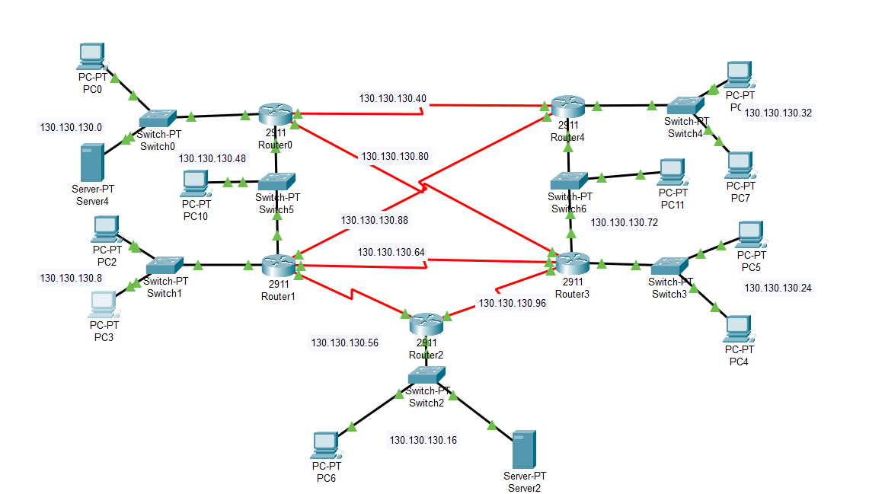
OSPF is configured before when the packet is sent from source to destination it shows the ip of particular pc when the packet is send
The packet is sent from PC1 to PC6
PC0 IP=130.130.130.33
PC6 IP=130.130.130.17
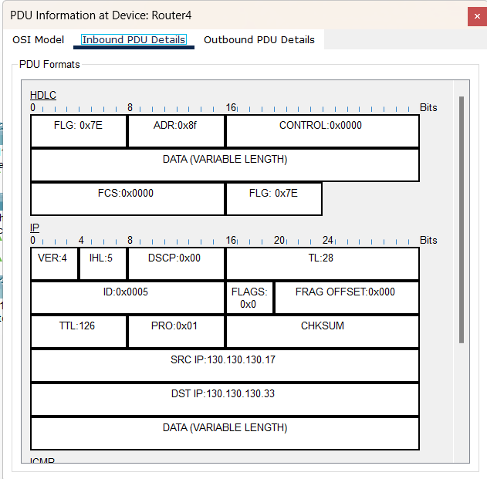

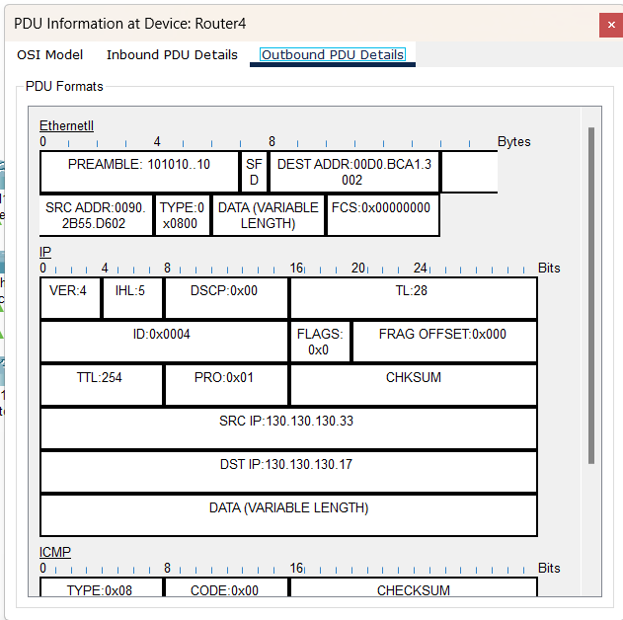
Configuring vpn on Router4 using the following commands:
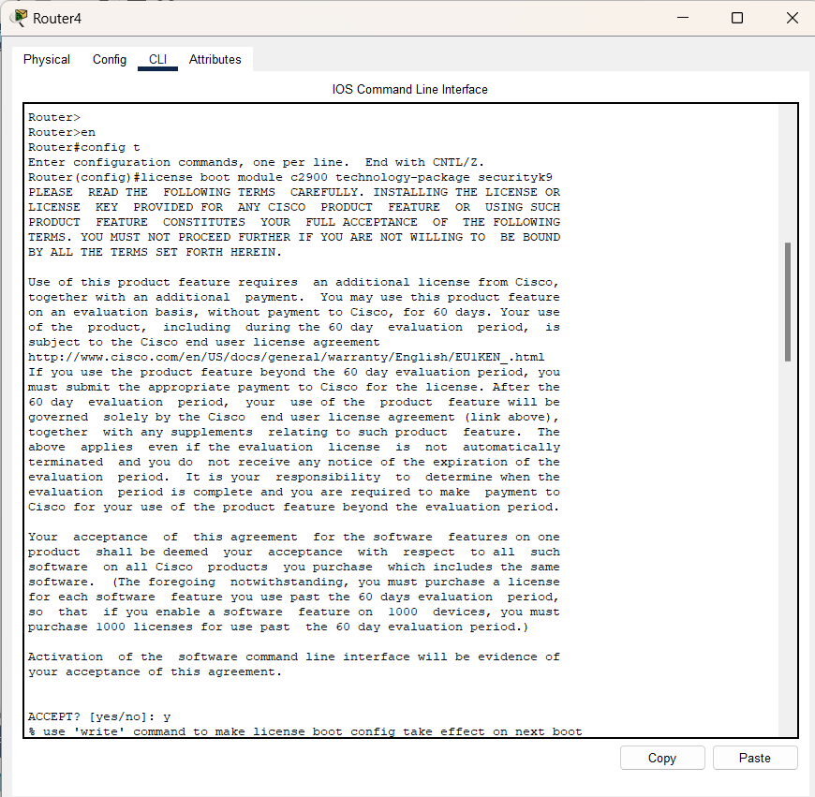
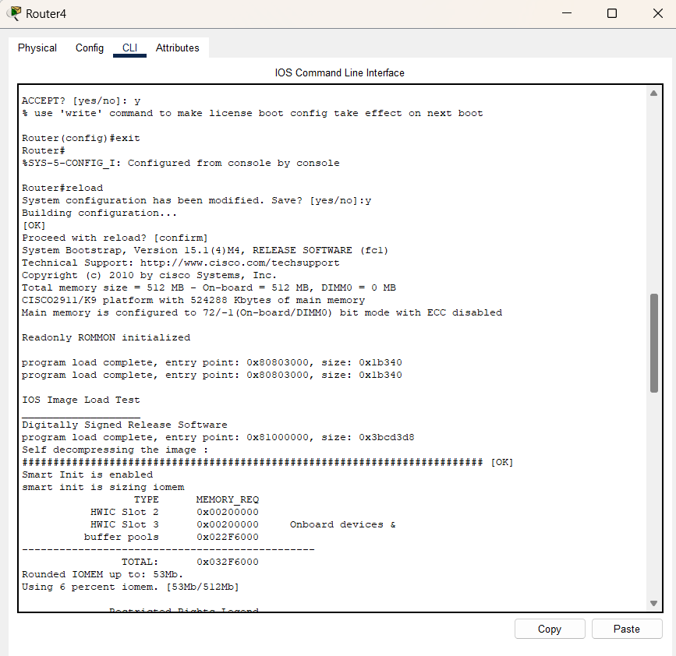
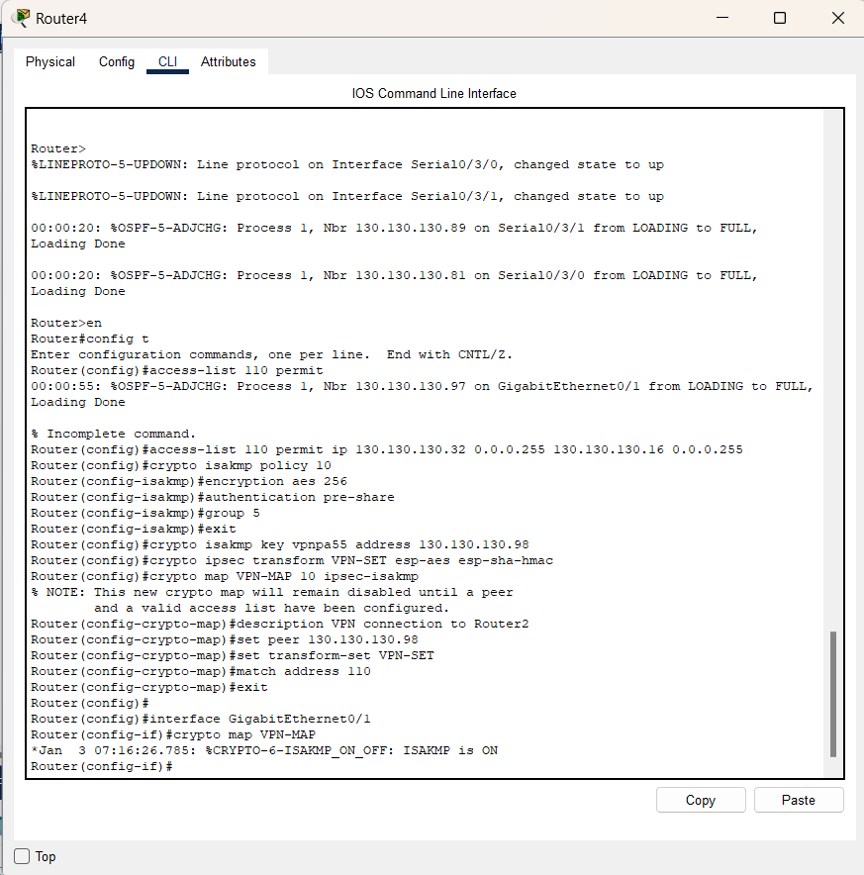

Configuring vpn on Router2 using the following commands:
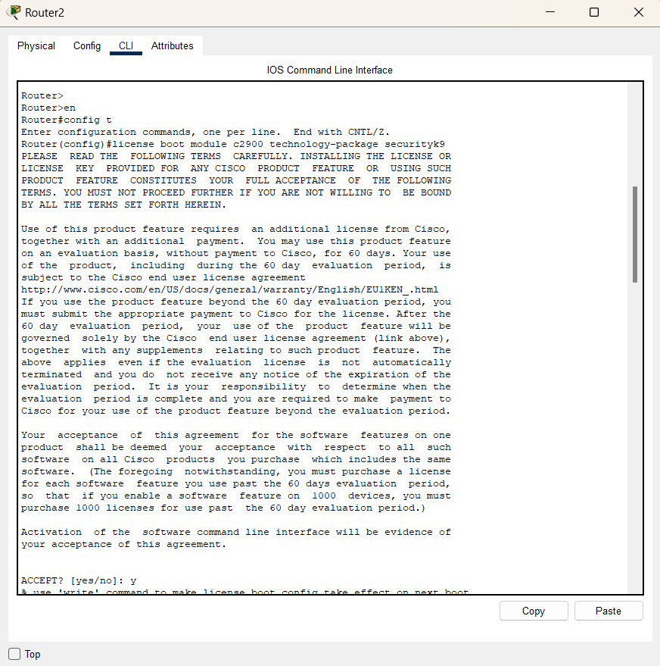
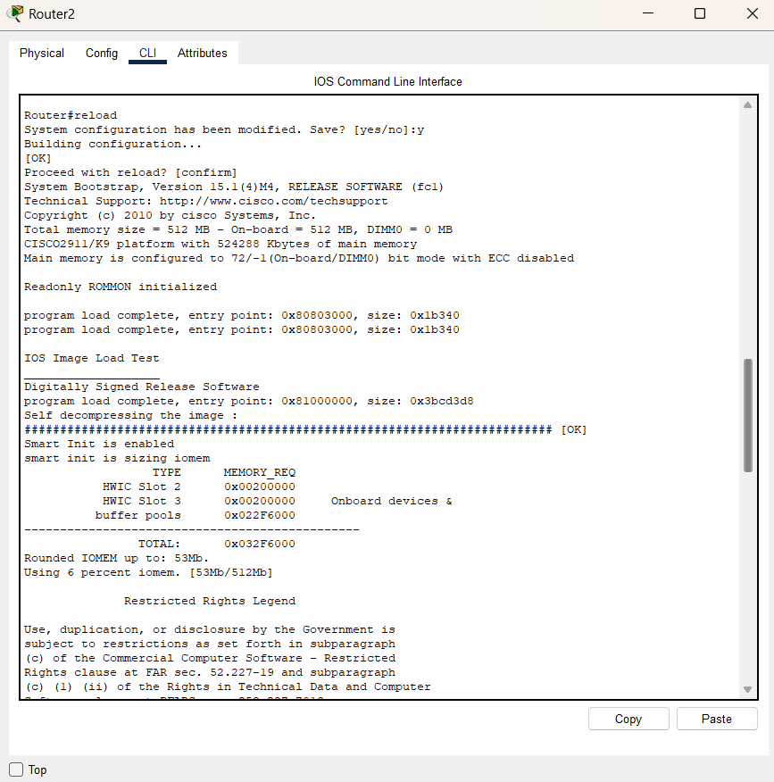

After Configuration of VPN,
packet show source IP and destination IP of interface from which route packet is routed
